***Lab 2-Task***

Class Concepts:

1: Class vs Object:

a) Class:

A class is a blueprint or template of creating objects. It defines a set of attributes and methods that the objects created from the class will have. However, a class itself is not a specific instance of data, it just provides the structure.



b) Object:

An object is an instance of a class. When a class is defined, no memory is allocated until an object is created from that class. An object is a specific entity that contains real data and can perform the actions defined in the class.

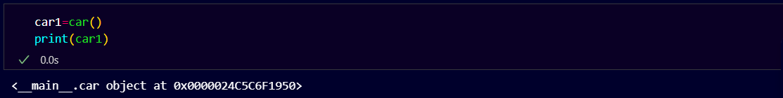

2.Constructor method:

a) __init__ function:

The __init__ method is called when an object is created from a class. It is used to initialize the object’s attributes with initial values.

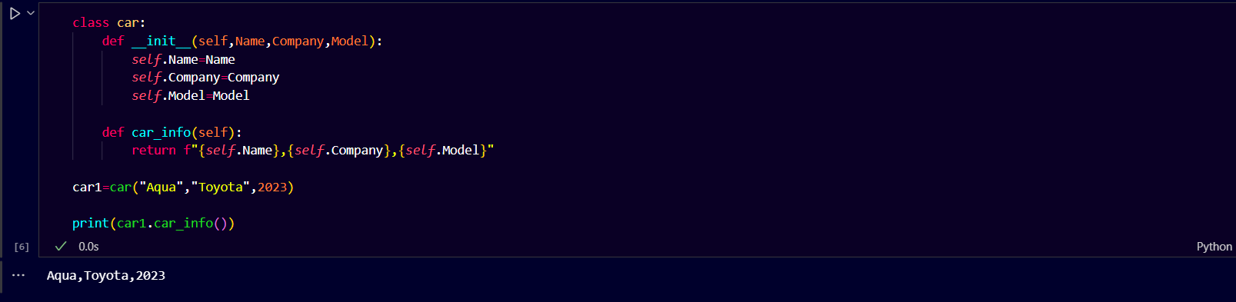

b) __str__ Function:

The __str__ method is called when you attempt to print an object or when you use str() to convert an object to a string. Without this method, printing an object would return a less informative default string representation, such as a memory address to the object.

